CD

|  |  |
| --- | --- |
|  | Automated Election system  A quick guide to voting. |

# Voter

Here is the process for voting:

1. Please enter your student number and password on the fields labeled for you on the screen, and press/tap the “Start voting!” button to enter.  
   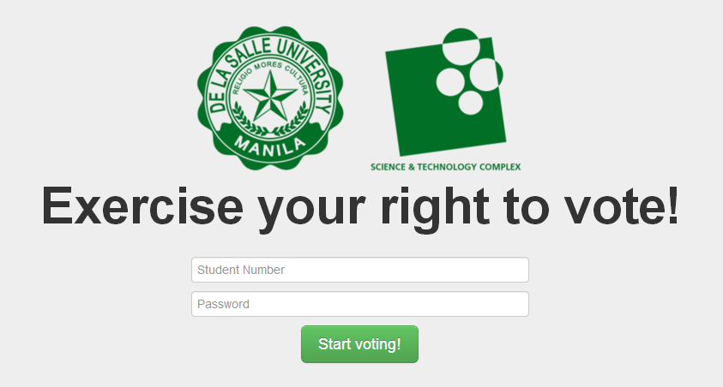
2. You will be shown the candidates page once your log-in details have been confirmed.
   1. If you are accessing the site from a desktop, you will be shown the following Candidates page  
      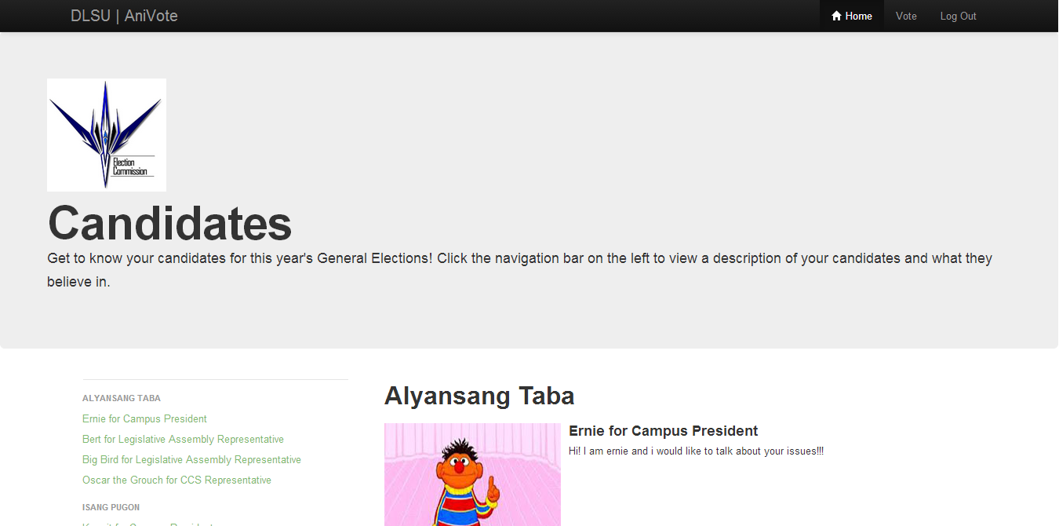
   2. If you are accessing the site from your mobile device, you will be shown the following Candidates page:  
      
3. When you are ready to vote, there are two options for you to enter the voting screen.
   1. You can scroll down the page and look for the “Start voting!” button. Move your mouse cursor over the button and left-click on the button, or if you are on your mobile device, tap on the button.  
      
   2. On the site’s navigation bar, if you are on the desktop version, move your mouse cursor over the “Vote” button and left click on the button to move to the next screen.  
        
      
   3. On the site’s navigation bar, if you are on the mobile version, tap the navigation button on the upper-right hand corner of the screen to bring up your options and click on the “Vote” option to move to the next screen.  
      

…then tap here to Vote

Tap here to bring up the options

1. You will be shown the following voting screen. Kindly left-click or tap on your choices, then click/tap “Submit my vote”.  
   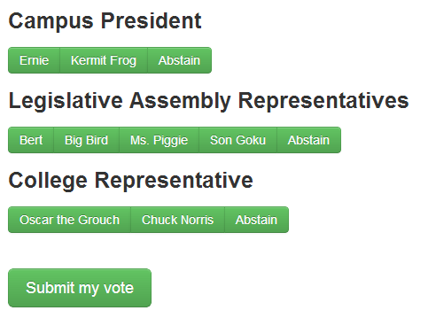
2. A pop-up will appear, asking you to confirm your choices. If you tap/click “No,” you will be brought back to Step 4 with your choices selected. Kindly click “Yes,” if you are sure of your vote.  
   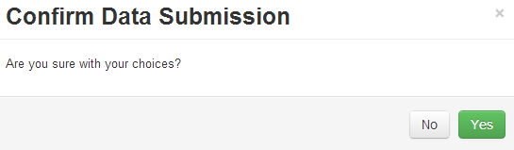
3. Once you are done voting, you will be brought back to the log-in screen. You are done!  
   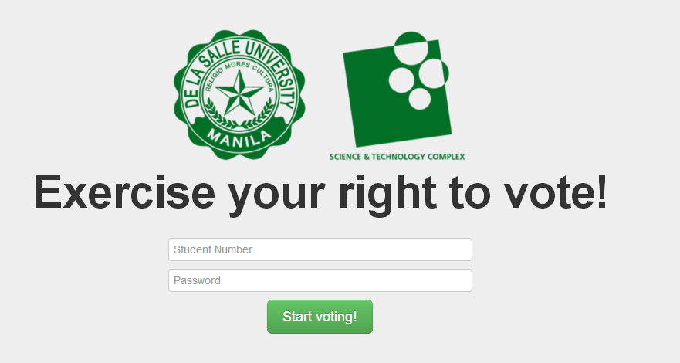

# Election Officer

1. Please enter your student number and password on the fields labeled for you on the screen, and press/tap the “Start voting!” button to enter.  
   
2. You will be shown the tally page once your log-in details have been confirmed.  
   